ACTIVITY
Name:B.Balakrishna reddy
Reg No:192424222
Scenario 1: Student Academic Performance Dashboard Learning Outcome Understand how position and color aesthetics represent different data types. Scenario The Head of the Computer Science Department wants to analyze whether students with higher attendance perform better in examinations. The department also wants to compare the performance across different programs. Dataset • Student ID • Attendance (%) • Internal Marks • Department (CSE, AI, IT, ECE) Student Task • Identify quantitative and categorical variables. • Map Attendance to the X-axis. • Map Marks to the Y-axis. • Represent the Department using different colors. • Add an appropriate title, labels, and legend.
Code:
library(ggplot2)
students <- data.frame(
StudentID = 1:12,
Attendance = c(75,80,85,90,95,88,70,65,92,78,84,89),
Marks = c(60,65,70,80,90,85,55,50,88,68,74,82),
Department = c("CSE","AI","IT","ECE","CSE","AI","IT","ECE","CSE","AI","IT","ECE")
)
ggplot(students, aes(x=Attendance, y=Marks, color=Department))+
geom_point(size=3)+
labs(title="Student Academic Performance",
x="Attendance (%)",
y="Internal Marks")+
theme_minimal()
output:
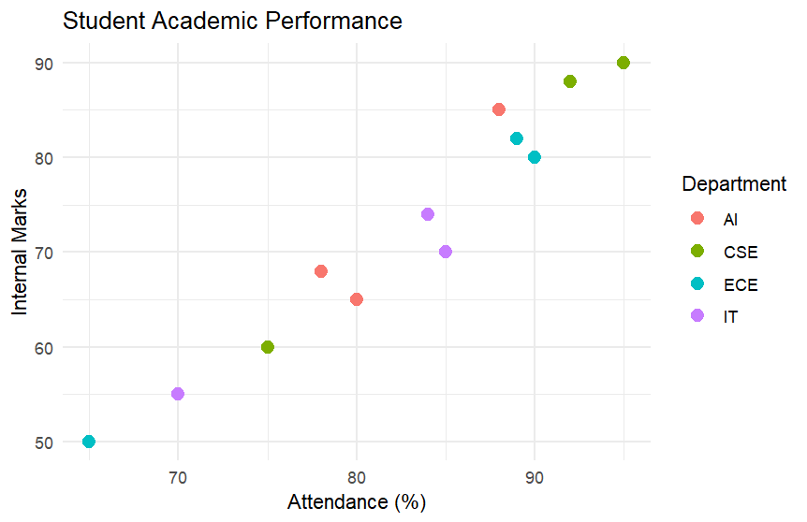
Scenario 2: Electric Vehicle Market Analysis Learning Outcome Learn how size and color aesthetics can simultaneously represent multiple variables. Scenario An automobile company is studying the relationship between battery capacity and vehicle price to understand whether larger batteries significantly increase the selling price. Dataset • Vehicle Model • Battery Capacity (kWh) • Price • Driving Range • Manufacturer Student Task • Plot Battery Capacity against Price. • Use Driving Range as bubble size. • Use Manufacturer as color. • Interpret whether larger batteries correspond to higher prices.
CODE:
ev <- data.frame(
Model=c("A","B","C","D","E"),
Battery=c(40,50,60,75,90),
Price=c(10,14,18,24,30),
Range=c(250,320,380,450,550),
Manufacturer=c("Tesla","BYD","Tesla","Tata","BYD")
)

ggplot(ev,aes(Battery,Price,size=Range,color=Manufacturer))+
geom_point(alpha=0.7)+
labs(title="Battery Capacity vs Price",
x="Battery Capacity (kWh)",
y="Price (Lakhs)")+
theme_minimal()
output:
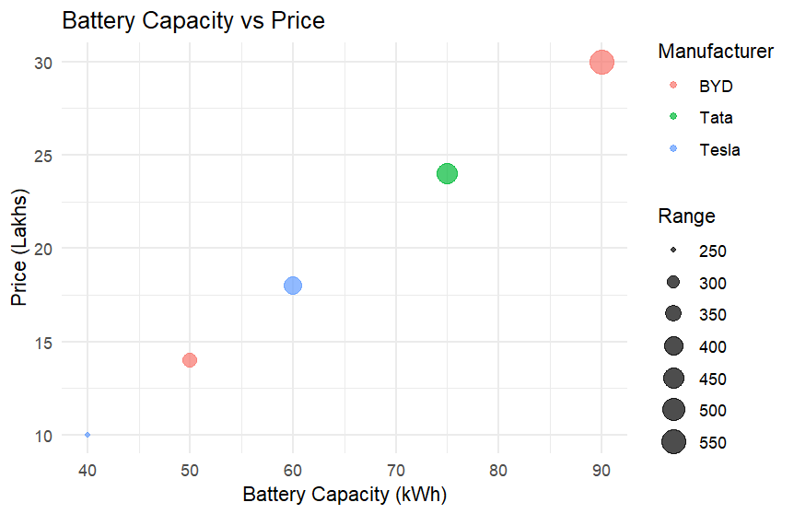

Scenario 3: Hospital Patient Admission Analysis Learning Outcome Visualize categorical variables using fill color and position aesthetics. Scenario A hospital administrator wants to compare patient admissions across departments during the last month. Dataset • Department • Number of Patients • Average Treatment Cost Student Task • Create a bar chart. • Use different fill colors for each department. • Display treatment cost as labels on the bars.
Code:
hospital <- data.frame(
Department=c("Cardiology","Orthopedics","Neurology","Pediatrics"),
Patients=c(120,95,80,150),
Cost=c(45000,35000,60000,15000)
)
ggplot(hospital,aes(x=Department,y=Patients,fill=Department))+
geom_bar(stat="identity")+
geom_text(aes(label=Cost),vjust=-0.5)+
labs(title="Hospital Patient Admissions",
y="Number of Patients")+
theme_minimal()
output:
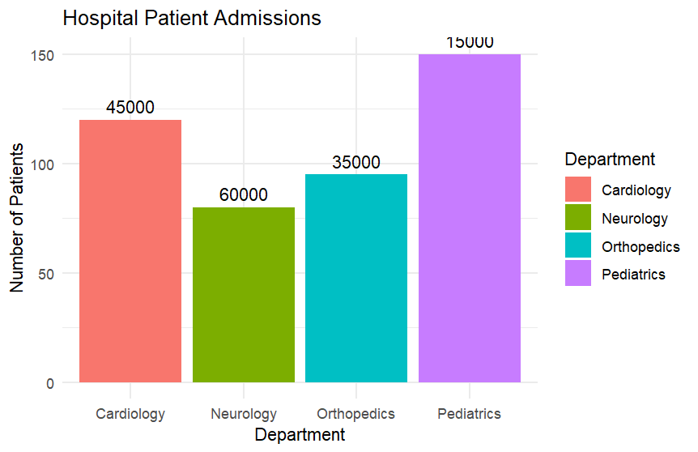

Scenario 4: Weather Monitoring System Learning Outcome Understand how line type and color distinguish multiple categories. Scenario The Indian Meteorological Department has collected daily temperature data for three cities over one month and wants to compare climate trends. Dataset • Date • Temperature • City Student Task • Draw a line chart. • Use different colors for each city. • Use different line styles for each city. • Compare temperature trends.
Code:
set.seed(100)
weather <- data.frame(
Date=rep(1:30,3),
Temperature=c(rnorm(30,32,2),
rnorm(30,28,2),
rnorm(30,25,2)),
City=rep(c("Chennai","Delhi","Bengaluru"),each=30)
)
ggplot(weather,
aes(Date,Temperature,
color=City,
linetype=City))+
geom_line(size=1)+
labs(title="Temperature Trends")+
theme_minimal()
Output:
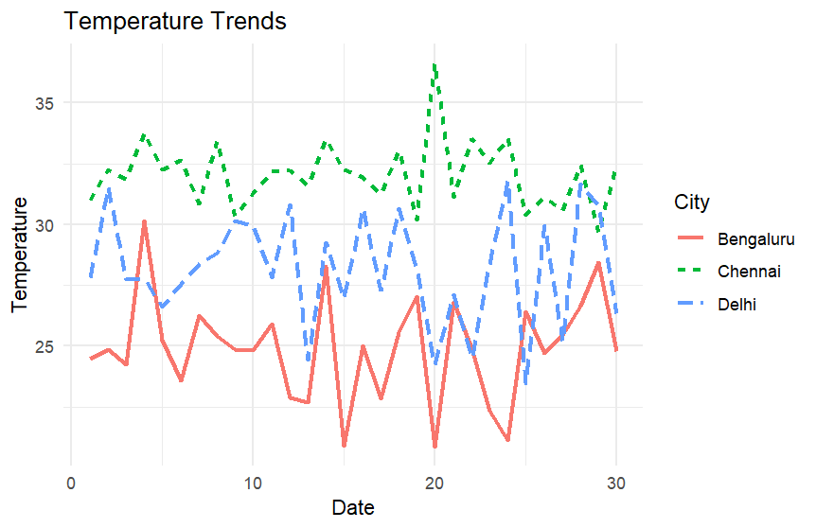
Scenario 5: Supermarket Sales Analysis Learning Outcome Apply position and fill aesthetics for grouped comparisons. Scenario A supermarket chain wants to identify which product categories generate the highest monthly sales across different branches. Dataset • Month • Product Category • Sales Amount • Branch Student Task • Create grouped bar charts. • Use branch as fill color. • Compare product sales among branches.
Code:
sales <- data.frame(
Month=rep(c("Jan","Feb","Mar"),each=6),
Category=rep(c("Food","Electronics"),9),
Sales=c(120,150,140,170,160,180,
130,155,145,175,165,185,
140,160,150,180,170,190),
Branch=rep(c("A","B","C"),6)
)
ggplot(sales,
aes(Category,Sales,fill=Branch))+
geom_bar(stat="identity",
position="dodge")+
facet_wrap(~Month)+
labs(title="Sales by Product Category and Branch")+
theme_minimal()
Output:
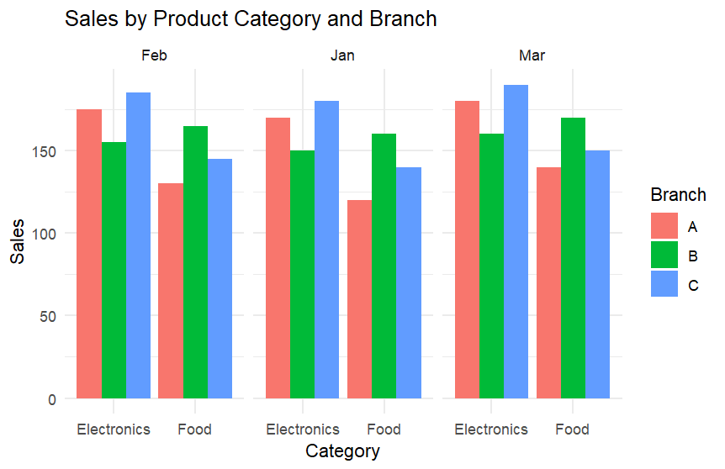

Scenario 6: Employee Salary Distribution Learning Outcome Understand continuous scales and histogram binning. Scenario The HR department wants to understand salary distribution among employees to determine whether salaries are evenly distributed across the organization. Dataset • Employee ID • Salary • Experience • Department Student Task • Create a histogram of salaries. • Experiment with different bin sizes. • Compare the effect of changing the scale.
Code:
set.seed(10)
employee <- data.frame(
Salary=rnorm(500,50000,12000)
)
ggplot(employee,aes(Salary))+
geom_histogram(binwidth=5000,
fill="steelblue",
color="black")+
labs(title="Salary Distribution")+
theme_minimal()
ggplot(employee,aes(Salary))+
geom_histogram(binwidth=10000,
fill="orange",
color="black")+
labs(title="Salary Distribution (Larger Bins)")+
theme_minimal()

Output:
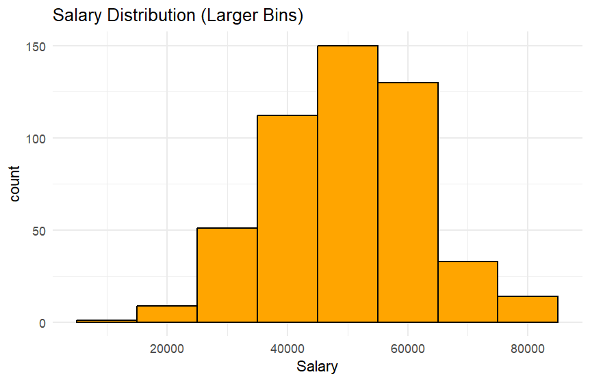

Scenario 7: Smartphone Market Comparison Learning Outcome Map multiple variables using shape, size, and color. Scenario A technology company wants to compare smartphone specifications to understand how RAM and processor speed influence product pricing. Dataset • Brand • RAM • Processor Speed • Price • Storage Student Task • Plot RAM against Price. • Represent Brand using shapes. • Represent Storage using point size. • Use color to indicate Processor Speed.
Code:
phones <- data.frame( Brand=c("Samsung","Apple","OnePlus","Xiaomi","Google"),
RAM=c(6,8,12,8,12),
Processor=c(2.2,3.1,3.0,2.6,3.2),
Price=c(30000,80000,50000,25000,70000),
Storage=c(128,256,256,128,512)
)
ggplot(phones,
aes(RAM,
Price,
shape=Brand,
size=Storage,
color=Processor))+
geom_point()+
labs(title="Smartphone Comparison")+ theme_minimal()
Output:
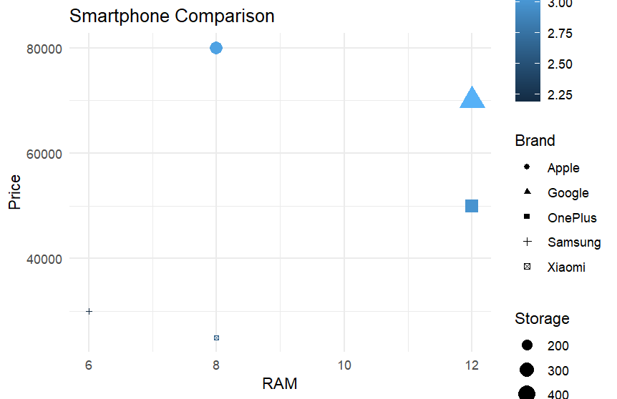

Scenario 8: Online Movie Rating Analysis Learning Outcome Understand continuous color scales and gradient aesthetics. Scenario A movie streaming platform wants to compare average ratings received by different movie genres over the past year. Dataset • Genre • Average Rating • Number of Reviews • Release Year Student Task • Create a heatmap. • Represent ratings using a color gradient. • Identify the highest-rated genres.
Code:
movies <- data.frame(
Genre=c("Action","Drama","Comedy","Horror","Sci-Fi"),
Year=c(2022,2022,2022,2022,2022),
Rating=c(4.1,4.6,3.8,3.5,4.7),
Reviews=c(2000,3000,1500,900,2500)
)
ggplot(movies,
aes(x=Genre,
y=factor(Year),
fill=Rating))+
geom_tile(color="white")+
scale_fill_gradient(low="yellow",
high="red")+
labs(title="Movie Ratings Heatmap",
y="Release Year")+
theme_minimal()
Output:
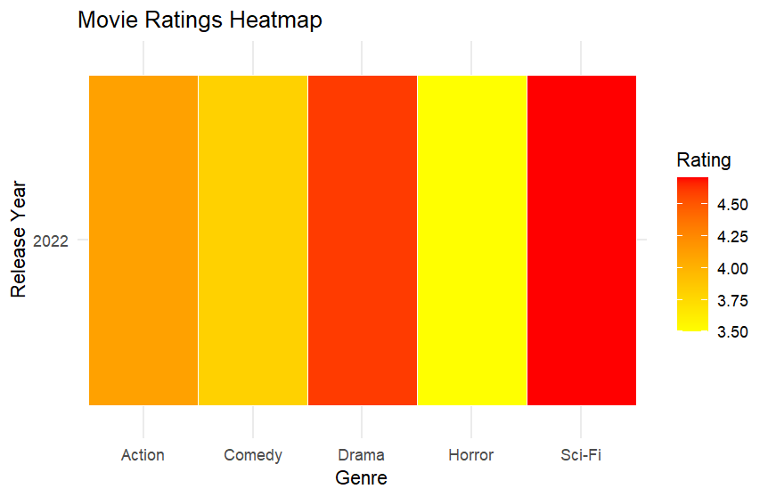

Scenario 9: COVID-19 State-wise Analysis Learning Outcome Understand sequential, diverging, and categorical color scales. Scenario The Ministry of Health wants to visualize the distribution of COVID-19 cases across different Indian states to identify highly affected regions. Dataset • State • Active Cases • Vaccination Percentage • Population Student Task • Create a choropleth map (or tile plot if maps are unavailable). • Represent Active Cases using a sequential color scale. • Compare the intensity across states.
Code:
covid <- data.frame(
State=c("Tamil Nadu","Kerala","Karnataka",
"Maharashtra","Delhi"),
Cases=c(5000,8000,6000,12000,4500)
)
ggplot(covid,
aes(x=State,
y=1,
fill=Cases))+
geom_tile(color="white")+
scale_fill_gradient(low="lightblue",
high="darkred")+
labs(title="COVID-19 Active Cases by State",
y="")+
theme_minimal()
Output:
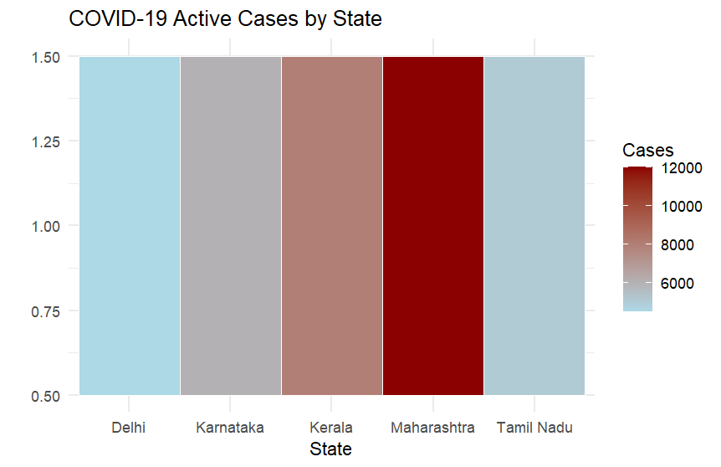

Scenario 10: Iris Flower Classification Learning Outcome Understand how multiple aesthetic mappings improve pattern recognition and class separation. Scenario A botanist wants to analyze flower measurements to determine whether different Iris species can be visually separated. Dataset (Built-in Iris Dataset) • Sepal Length • Sepal Width • Petal Length • Petal Width • Species Student Task • Plot Sepal Length against Petal Length. • Use Species as color. • Use Species as shape. • Use Sepal Width as point size. • Interpret whether species form distinct clusters.
Code:
data(iris)
ggplot(iris,
aes(Sepal.Length,
Petal.Length,
color=Species,
shape=Species,
size=Sepal.Width))+
geom_point(alpha=0.8)+
labs(title="Iris Flower Classification",
x="Sepal Length",
y="Petal Length")+
theme_minimal()
Output:
